SUPERCOMEDIT V2.xx

user’s

Manual

This manual may be slightly different from the software released
2006.08
Chapter One: Installation and network setting 4
1.1 Connecting LED to the PC 4
1.2 Installation 4
1.3 Network parameter 5
Chapter Two: Main interface 7
2.1 Toolbar Button 7
2.2 Schedule 8
2.3 Playing property 9
2.4 Simulation Displaying Region 9
Chapter Three: Parameter setting 10
3.1 Hardware 10
3.2 LED 11
Chapter Four: Making Program 12
4.1 Adding program 12
4.2 Playing time of a program and size of area 13
4.3 Timing play and space between areas 13
4.4 Add playable document 14
4.5 Delete document or program 15
Chapter Five: Sending schedule to the LED 16
5.1 Arrangement data 16
5.2 Transfer schedule 16
5.3 Using SD Card 17
Chapter Six: Design the Clock Page 19
6.1 Background Text 19
6.2 Clock String 20
6.3 Counter String 20
6.4 Temperature and Humidity 20
6.5 Serial port data 21
Chapter Seven: Run-time Information, Updating and Safety 22
7.1 Run-time Information 22
7.2 Updating 22
7.3 Safety 23

Chapter One: Installation and network setting
1.1 Connecting LED to the PC
The LED-controller is accessed by Ethernet LAN.
The two pictures below show the RJ45’s first pin position and EIA/TIA ’s standard 568A and 568B, which stipulate two kinds of twisted pair cable’s order.
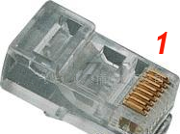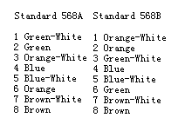
When PC directly connects to the LED, one end of the cable would adopt 568A while the other end would adopt 568B.
If PC connects to the LED by Router, HUB or Switch, two ends of the cable would adopt 568B.
1.2 Installation
Running the SCEditSetup.exe program, there will be a window appear on the screen as followed:
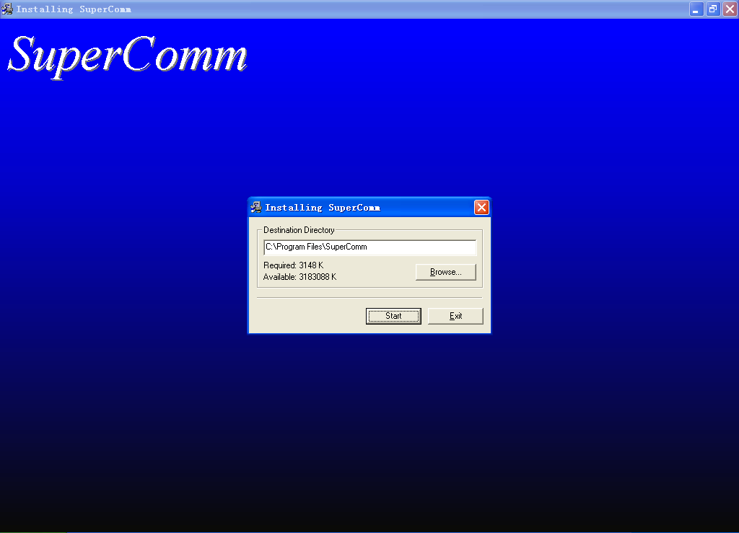
Click [start], and then the SUPERCOMEDIT software will be installed into the computer, and a shortcut to the SuperComm will be created automatically.
After completing the setting up procedure, the size of the LED can be modified, and programs can be made. But before sending the finished program to the LED, the network parameters must be set.
1.3 Network parameter
When running SUPERCOMEDIT for the first time, relevant parameters must be set. Before setting the parameters, confirm the controller’s power supply was turned on, and the net cable was connected.
In the main interface of SUPERCOMEDIT, click [Option] button or choose [Tool]->[Option] in the menu to start to set the parameters.
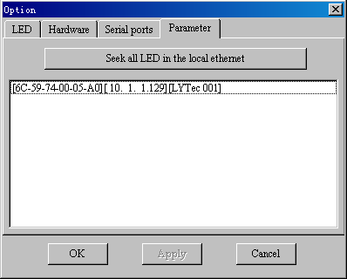
In parameter setting window, choose the card [parameter], and then click [Search all the display in the local Ethernet]. All LED controllers’ MAC address and IP address as well as alias name connected in the LAN will be put in the following list. Double click the item that needs modifying, following interface will appear on the screen:
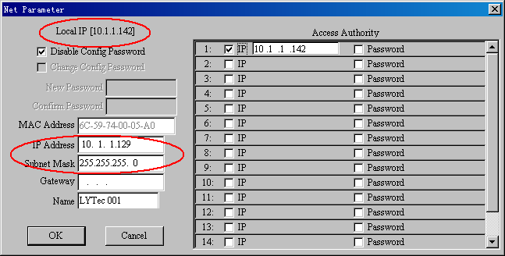
Input the IP address and subnet mask as well as the gateway according to the local IP. Also you can give a name to the controller.

Chapter Two: Main interface
Run SUPERCOMEDIT, the program main interface will appear on the screen.
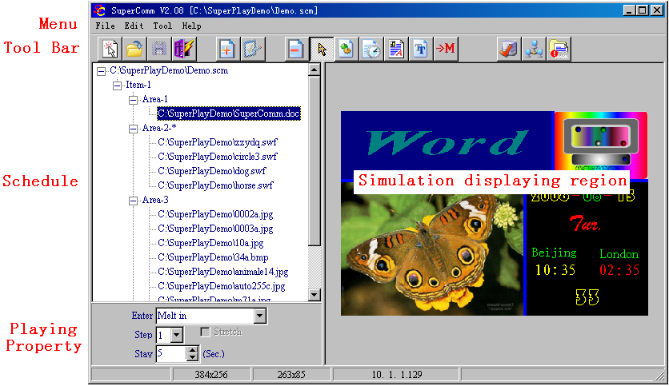
2.1 Toolbar Button
Above the interface, there are four types of buttons in the toolbar. They are,
- The schedule operation, includes, [New], [Load], [Save] and [Exit]
- [New]: Clear the schedule and simulation displaying region, start to make a new schedule
- [Load]: Load the existed schedule
- [Save]: Save the edited schedule
- [Exit]: Exit the SUPERCOMEDIT program
    - Program operation, including [Add], [Delete], and [Property]
- [Add]: Add a new program, which will cover full space of the screen, and can be divided into many areas, and each of them includes many documents.
- [Delete]: Delete a document in certain area or delete a program. As for the area which can not be deleted (deletion can only be achieved by moving the segmentation line to narrow certain area)
- [Property]：When choosing a program in the schedule, click [Property], the space between the areas and the program’s timing attribute concerning displaying can be modified.
- Editing operation, which includes [Empty], [Add files], [Add Timer], [Add RTF], [Add Text] and [Switch Main Area]. After clicking an editing button, and then click the left button of the mouse in certain rectangles, the computer will do respective editing operation.
- [Empty]: Cancel the choice concerning other editing buttons before.
- [Add Files]: Add one or more documents in a certain area.
- [Add Timer]: Add a clock displaying item in a certain area.
- [Add RTF]: Immediately input content, after adding a RTF option in certain area. The font, color and alignment of the RTF can be modified by clicking the right button of the mouse in the area.
- [Add Text]: Add a text in a certain area, which is similar to the RTF. Although the TEXT can not realize single or partial change in Font and color, it can still realize very intensive character arrangement.
4. System operation: This includes [option], [Remote Management] and [Runtime Information]
- [Option]: To realize the parameter setting mentioned in 1.3 and chapter Three.
- [Remote Management]: To realize document uploading mentioned in chapter Five.
- [RunTime Information]: To get the runtime information mentioned in chapter Seven.
2.2 Schedule
In the left part of the main interface lies the schedule, which can be divided into four levels,
      - The top node is the schedule’s name. If it is a new schedule, the top node will only be shown as “new program list”.
      - On the second level lies the program and each of them contains one or more areas.
      - The third level is the area. And each of them contains many items. There are several areas under the same program. What’s more, there is a major one in all these areas (with an asterisk after it). The playing time of this area will decide the playing time of this program.
      - On the fourth level lies the item, which can be SWF (Flash animation), Word document, BMP or JPG picture, RTF document, TEXT document and Clock item.
In the schedule, items can be directly dragged from a area to another, or dragged to another program.
If the item is Word document, double click this item to make the computer automatically run Word editing, and do offline composition.
If the item is a picture (BMP or JPEG picture), double click this item to make the computer automatically run Windows’s brush program to edit this picture (In Windows XP), or run the Browser (In Windows Me).
If the item is a Clock item, double click this item to start clock item’s editing procedure.
2.3 Playing property
Playing property includes animation, moving dots and stay time. For picture items, automatically zoom property can be selected.
2.4 Simulation Displaying Region
On the right side of the main interface, there is the simulation-displaying window. If the current item in certain area is RTF document or TEXT document, one can directly input or modify the content. By right-button menu, the Font and color can be modified. As for the RTF document, the Font, size, and color can changed in single or partial content. However, as for the TEXT document, the Font, size and color can only be modified totally.
If the current item of the area is Clock, there will appear the design accordingly in that area.
If the current item in the area is Word document, there will appear “Word” only in that area.

Chapter Three: Parameter setting
As in Chapter One, 1.3, start parameter setting procedure.
3.1 Hardware
Only the engineer can set the hardware parameter. If improper setting occurs, it would be possible to damage the LED display. Do hardware parameter’s modification carefully. Before accession into the hardware setting, the password should be provided. If the password given is incorrect, the SUPERCOMEDIT will change into another setting interface, and forbid to do hardware setting.
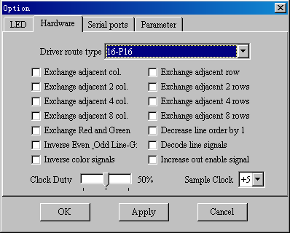

The LED driver board and the wiring method can be described as XX-Pyy [-nn…] format. In it XX is considered to be a scanning model, which are 16(1/16 scanning), 08(1/8 scanning), 04 (1/4 scanning), 02 (1/2 scanning) or 01 (static) respectively; yy describes the single data signal line controlled rows. Generally, they are 02,04,08 or 16.Very few of the displaying board could possibly be 01; nn could be many situations for choice. Referring to the connection between the driver IC and the light, the column should be described first and then the rows.
On the driver board, which are in accordance with the above mentioned wiring way, there may still exists driver pin connect order disagreement problem. However, this issue can be improved by choosing to exchange certain rows or columns in each group.
Scanning clock duty ratio is used to adjust the high and low level’s proportion in the clock signal given by controller. When data needs to be transmitted to relatively far distance in horizontal direction, this option will be very useful, for it can guarantee the data signal be transmitted to the remotest part of the LED display.
3.2 LED
LED Setting is a relatively common setting option. Before making schedule, the size of LED display should be specified here. If the display has already connected, the turn-on, turn-off time can specified, and the relative lightness of the different color can be modulated.
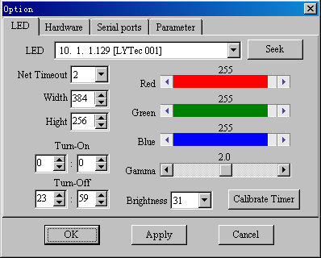

Chapter Four: Making Program
4.1 Adding program
Click [Add] button, and then there will be a dialog for choosing template appears as followed,
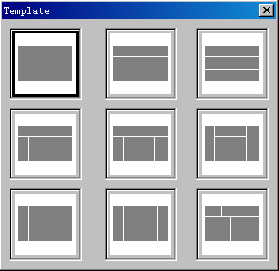
Double click the left button of the mouse in the needed allocation model. In this way, one adds a multi-area program option in the schedule.
4.2 Playing time of a program and size of area
A program is composed of several areas, and each of the area can play several pictures, Word document, RTF document, TEXT document, Flash animation or clock.
While, there is only one major area in each program, which decides the playing time for a program. And other areas are called sub-areas. If all the documents in the major area finished playing, the program also finishes playing. If the sub-areas finish playing, but the major one doesn’t, the sub-areas will recycle automatically. In the schedule, the area with an asterisk after it is the major one.
The splitter line within the areas can be dragged to change the size of them.
4.3 Timing play and space between areas
Choose certain program, and then click [Property] button, the timing option for the program and space between each area of this program can be modified.
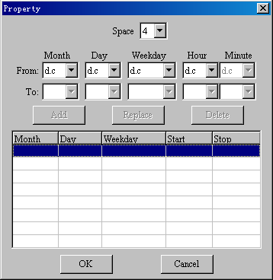
Note: “d.c” means “Don’t care”
4.4 Add playable document
Click [Add file] in the toolbar and then click the area where the document wants to be put in. At last, choose the document.
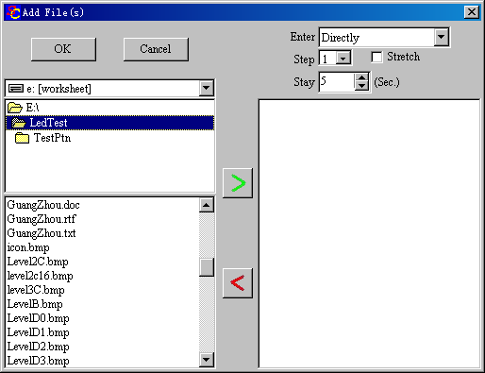
Find the document’s saving place, there will be the playable documents names listed in the lower part of the document form. Choose one or more documents, and click the “>” button to add these documents into the list on the right.
In the upper right part, these documents accession way and moving dots as well as staying period can be chosen. If it is picture, the automatically zoom property can be selected.
Attention: Display method is of no effect on Flash animation and clock playing item.
4.5 Delete document or program
In the schedule, choose the document (item) or the program, which needs to be deleted, and then click [Delete] button in the Toolbar so the content chosen can be deleted.

Chapter Five: Sending schedule to the LED
5.1 Arrangement data
Press [Remote management] button in the tool bar, and firstly the program will suggest you whether you need to readjust the data. In order to save the storing room, SUPERCOMEDIT program will condense the relatively larger picture into the size which is the same as the playing area, and delete the useless color within it. In addition, the program also needs to segment Word, RTF and Text document, so intercept the Flash animation picture generally needs undergoing arrangement process.
Under certain circumstances that there are Flash animations in the schedule, the needed time for arrangement is relatively long. Please wait for a moment.
If you just want to send the original schedule to another LED display, you can skip the arrangement process.

5.2 Transfer schedule
After the arrangement process, there will appear a document sending and receiving window.
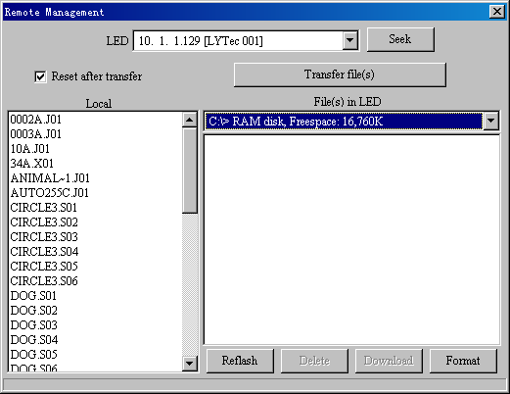
One can choose to make the LED controller boot again after sending the document and start playing new schedule.
In the left lower part, is the collated total content of current schedule (c:\superplay.tmp). If none of the documents was chosen, the SUPERCOMEDIT will send all the documents.
On the right side, there lie the total documents in certain driver of the controller. Different driver’s space and document catalogue can be checked. During the document sending process, the documents are always stored in the currently chosen driver of the controller.
The lower right part button provides operation concerning deletion of certain document in the controller, downloading certain document and formatting controller’s certain driver.

5.3 Using SD Card
If the SD card is used to store schedule document, the USB-SD card reader can also be used after arrangement all schedule documents, and just copy all the documents from the C:\superplay.tmp to the SD card’s root catalogue, and then insert the SD card back into the controller.
The schedule searching order for the controller is: Disk-C, Disk-B. Finding out the schedule document playlist.ly in any driver can play the schedule immediately.
If the entire schedule documents have sent to Disk-C, but the controller powers off, the schedule will be lost totally.

Chapter Six: Design the Clock Page
Press the [Add Timer] button in the Toolbar, and then click the area where the clock-item lies, or double click the clock item in the schedule, the window for designing clock page will be opened.
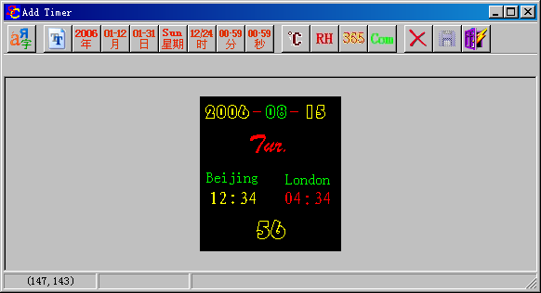
In the window of designing clock page, the upper part is the Toolbar, and the lower one is the simulation area.
In the leftmost part of the toolbar, there is the button for modifying certain string’s Font, Size and Color. And then from left to right, there are materials for designing the clock: [Text], [Year], [Month], [Date], [Week], [Hour], [Minute], [Second], [Temperature], [Humid], [Counter], [Serial-port data].
These three buttons on the right are used to delete certain string respectively, or to save the design already made, or to exit clock page’s designing.
6.1 Background Text
Press [Text] button in the Toolbar, and then click the position, which places text in the simulation area. In the input frame below the toolbar can modify the text content. These texts will constitute the background text in the clock page. During the clock displaying process, these texts’ content will not be changed.
6.2 Clock String
Press [Year], [Month], [Date], [Week], [Hour], [Minute], or [Second], and then click simulation displaying area to place these clock strings. When the clock string is playing in the display, controller will draw the string from the controller’s clock.
Attention: [Hour] string has a time zone attribute frame for choosing (in the right lower part of the Toolbar). When one placing [Hour] option, the computer will automatically choose the user’s time zone, but it can also choose different time zone.
6.3 Counter String
Press [Counter] button in the toolbar, and then click within the simulation displaying area where the counter string placed, so the countdown item is added.
The counter option can choose “Hide leader zero”, “Original”, and “Bits” as well as “Count Direction” options etc.
6.4 Temperature and Humidity
Press [Temperature] or [Humidity] button in the toolbar, and then click in the simulation display area where the temperature and humidity string placed, so the temperature and humidity string can be added.
Attention: Displaying temperature and humidity needs connecting sensors to the controller.
6.5 Serial port data
Press [Data from Serial port] button in the tool bar, and then click in the simulation displaying area where the data string lies, so the serial port data string can be added.
As there are varied external equipment’s serial port communication formats, so the program that is used to identify the serial port data needs trusting others to develop it.
There are three serial ports on the controller-they are Baud rate, data bits, stop bits, and check bit etc. which can be set in [Option] dialog mention in chapter three. Just like hardware parameter setting, the serial port setting also needs inputting password.
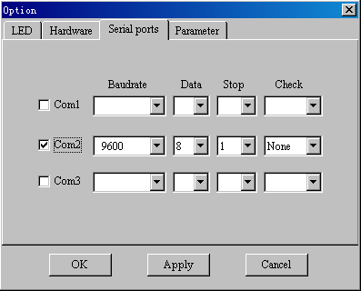

The data sent to the controller’s serial ports must be formatted as follow:
Nx1,x2,……,xn+[Enter]
Here, N is the ASCII upper-case character ‘N’，x1-xn are eight ASCII datum Each data can only be combined with space, point, digit, ‘+’, ‘-’. x1-xn are separated by ‘,’.

Chapter Seven: Run-time Information, Updating and Safety
7.1 Run-time Information
Click [RunTime Information] button in the Toolbar, and it will show the running status of the LED screen as followed,
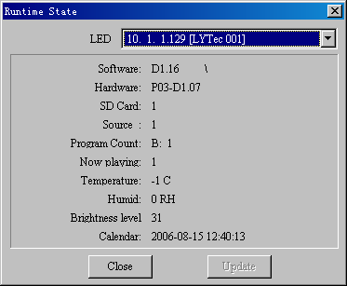
There are software edition, hardware edition, SD card status, and the power switch situation of the LED display, driver which currently plays the schedule, the program count, and currently played program’s number, peripheral sampling data as well as controlling card’s clock, etc.
7.2 Updating
If the controller playing software edition released along with the SUPERCOMEDIT package and hardware configuration are higher than the current edition in the controller, the [Update] button will turn to be operative. After clicking the button, it will automatically upgrade to be relevant part on the controller.
7.3 Safety
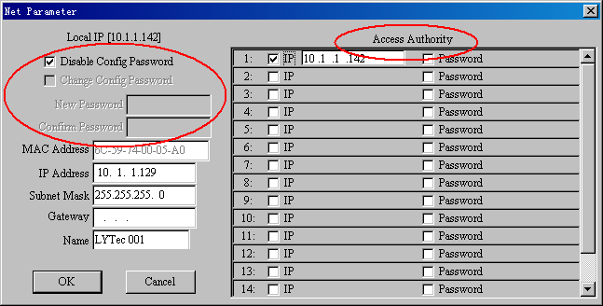
(In Parameter setting process, mention in chapter One 1.3) If wants to prevent irrelevant personnel from modifying the net parameters willingly, the config password can be set. If this is on, SUPERCOMEDIT will confirm the password before modification of the network parameters in above not be set.
Because the controller is connected to a computer by LAN, so whenever there is a computer runs SUPERCOMEDIT software in the LAN, it can control the LED display.
In order to prevent irrelevant personnel from sending data to the display willingly, the SUPERCOMEDIT can set these access authorities, Only some computer with certain IP can access the controller, or only somebody owned the accession password can access the controller, or both of them. At most, sixteen IPs and sixteen passwords can be set for one controller.

